James Brown

CSD 340

Web Development with HTML & CSS

Module 7.3 – bioSite: Development

10/03/2022

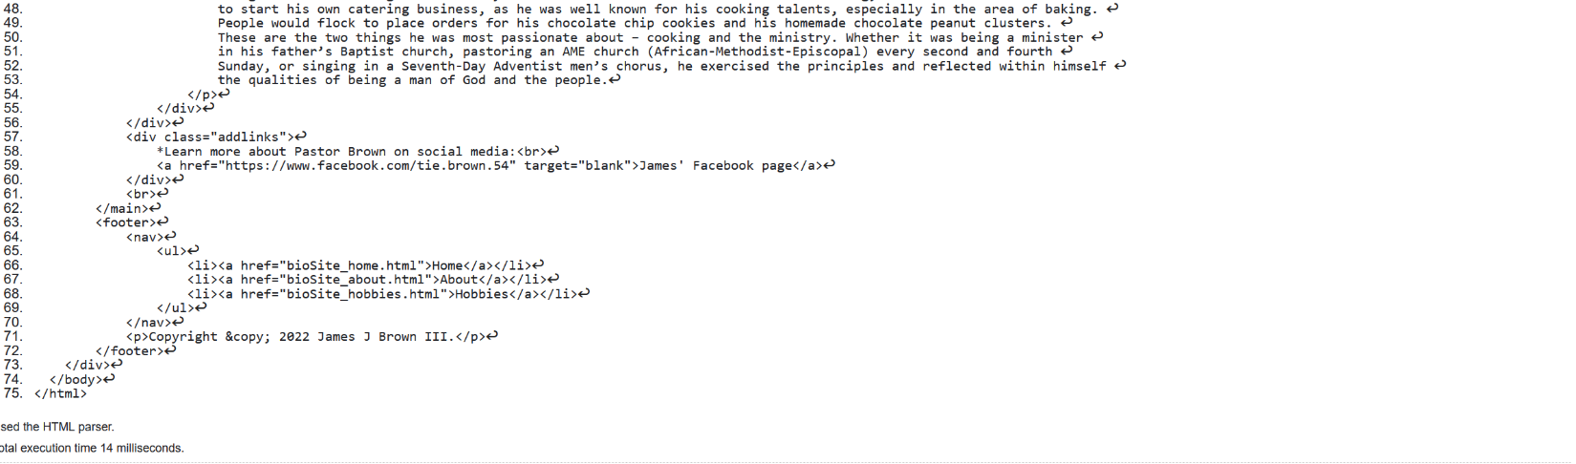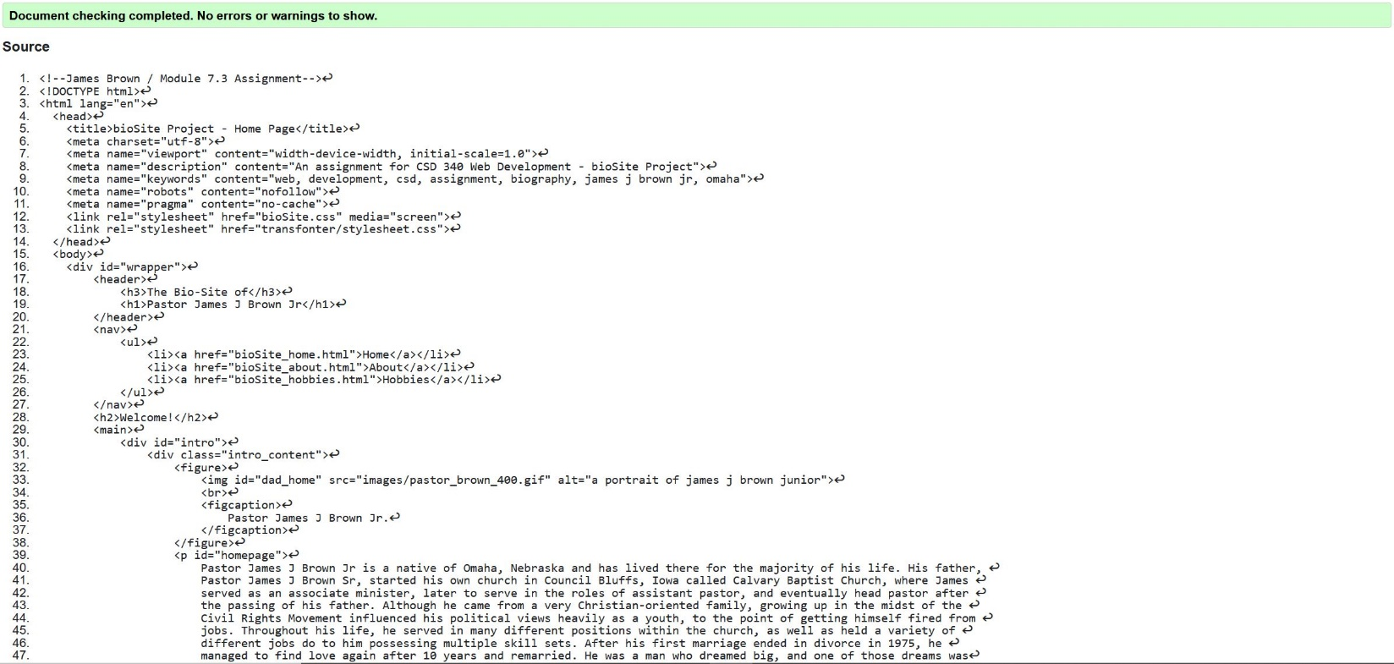**Screenshot 1: bioSite Home Page**

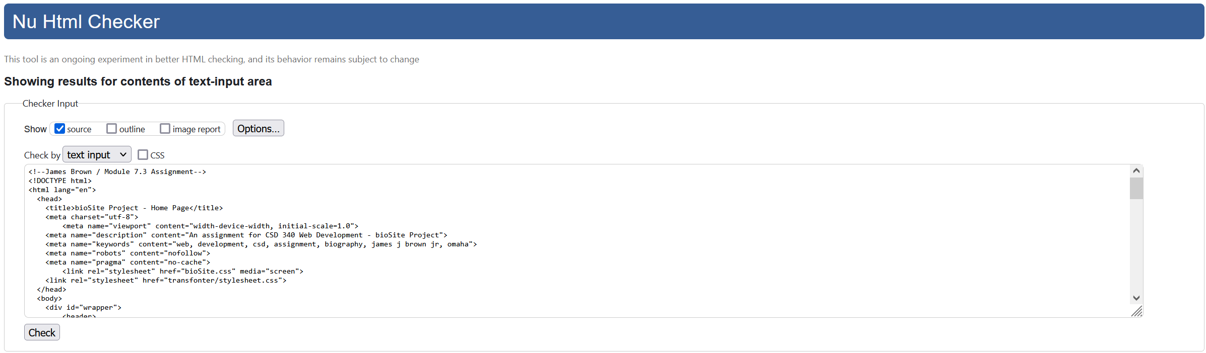

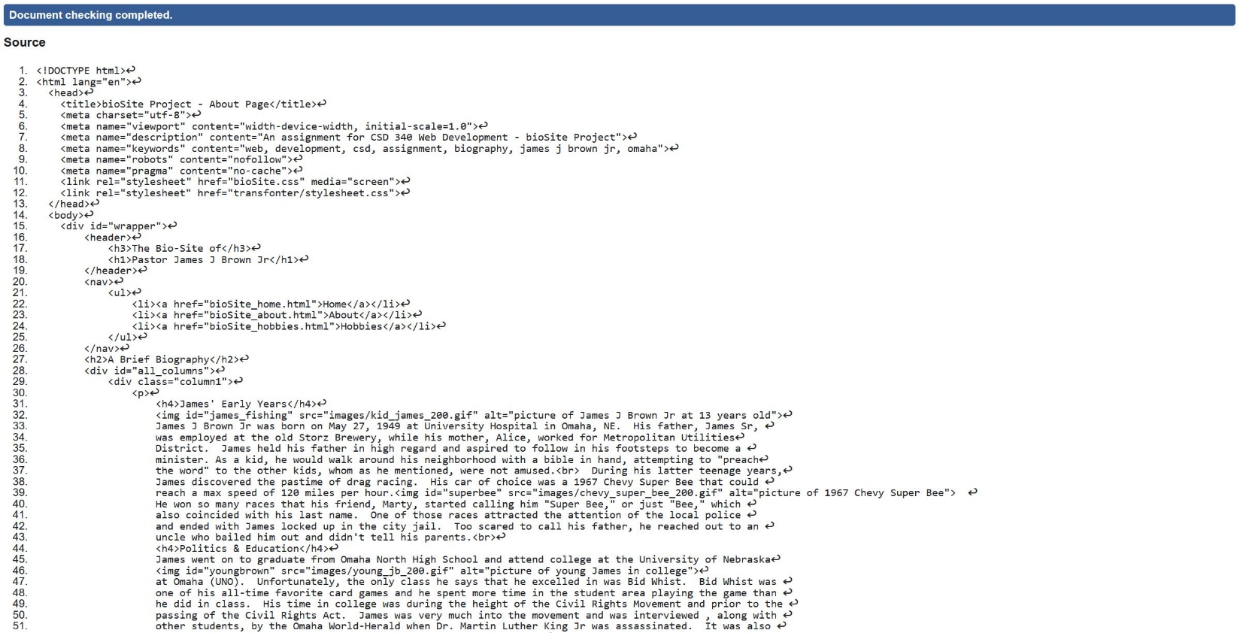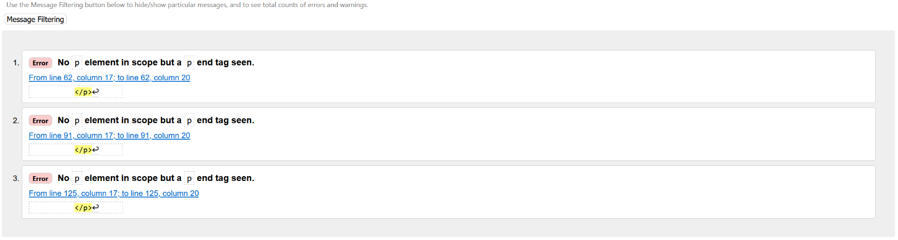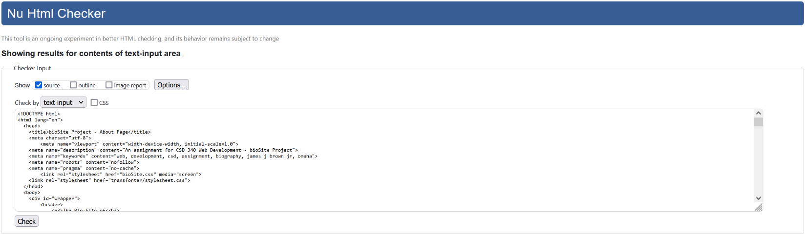**Screenshot 2: bioSite About Page**

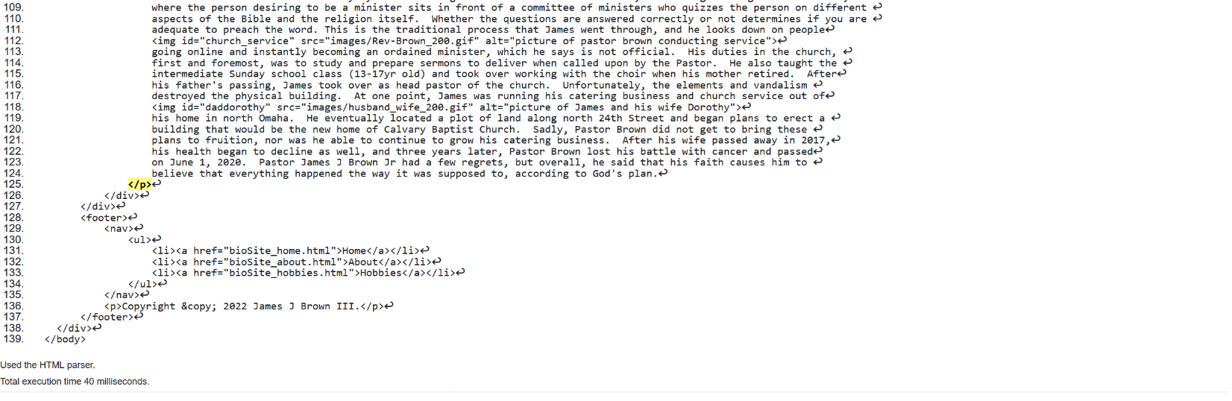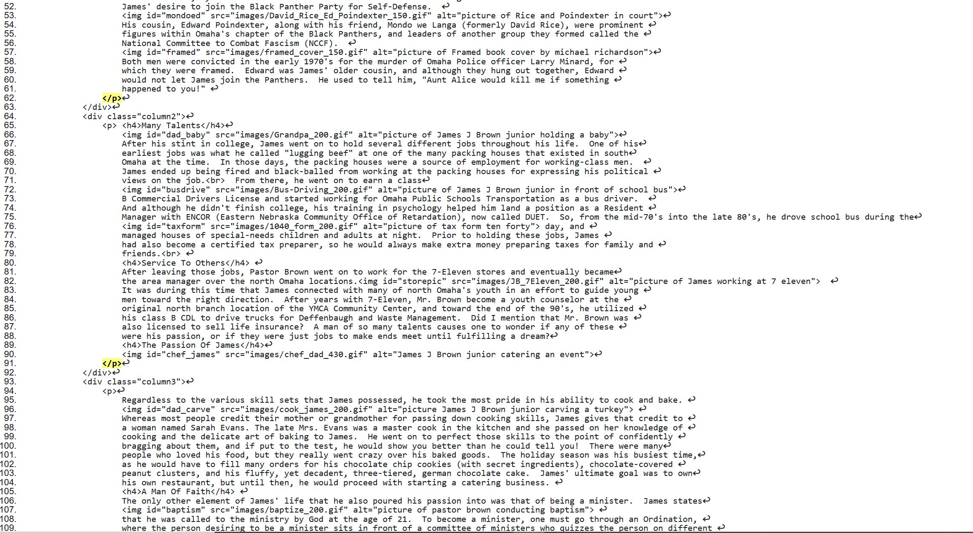**\*\*I don’t understand the error that it’s throwing. I have both opening and closing paragraph tags.**

**Screenshot 3: bioSite Hobbies Page**

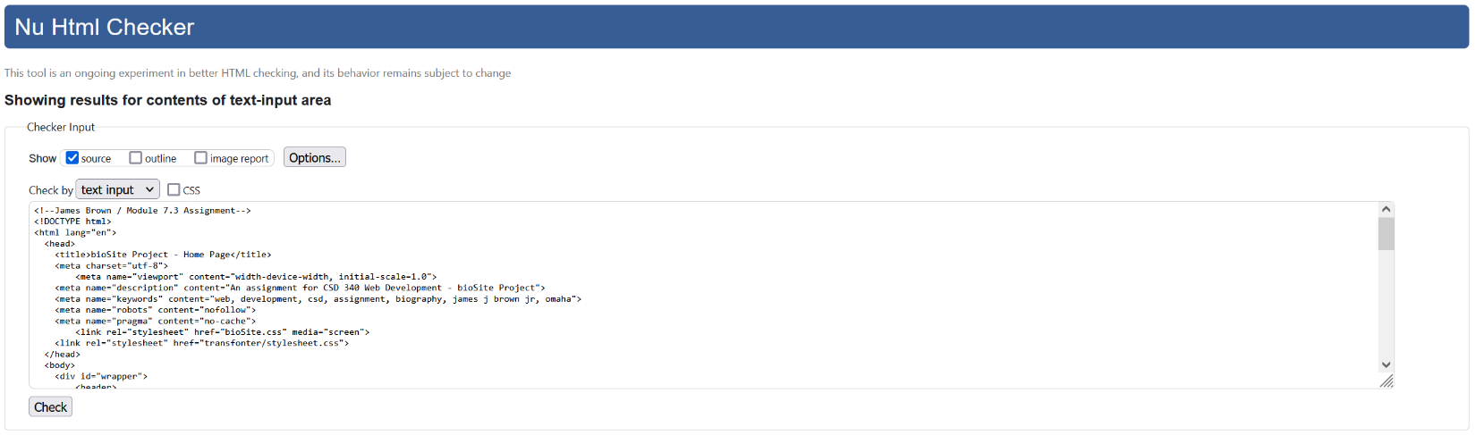

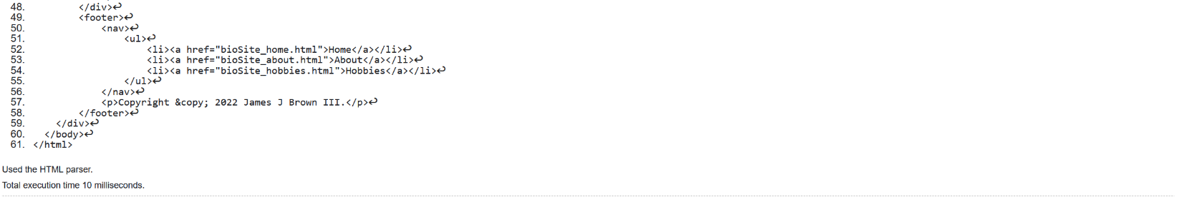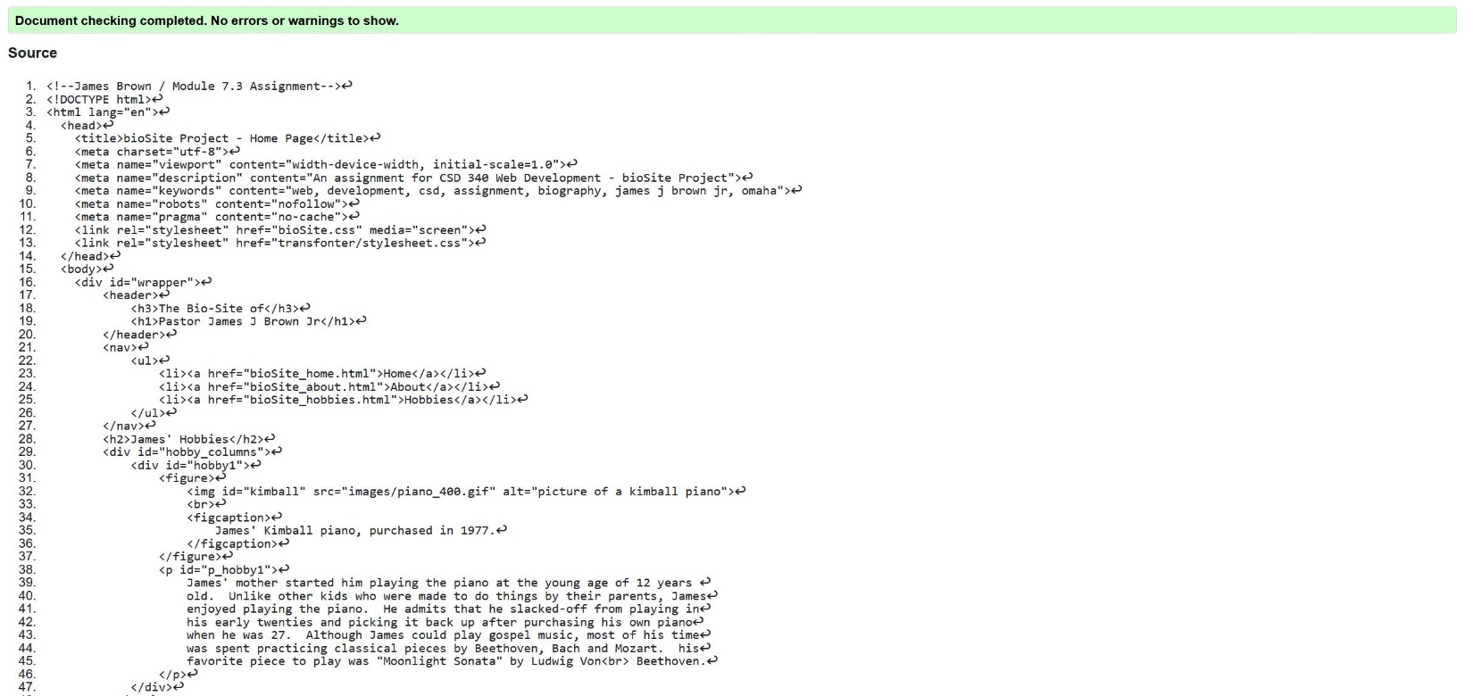

**Screenshot 4: bioSite CSS Stylesheet**

